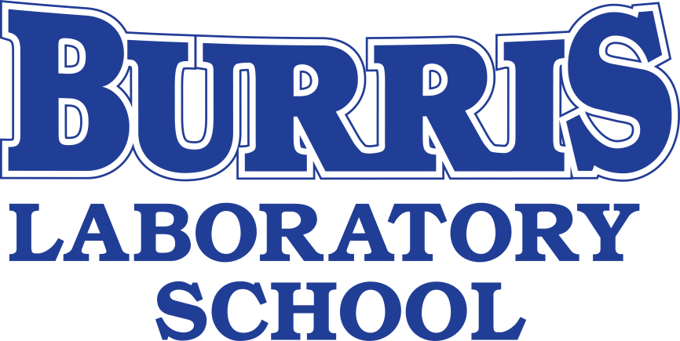

SECONDARY SUPPLY LISTS
2020-2021

GENERAL SUPPLIES FOR ALL CLASSES 2
PE Supply List 3
Innovators & Makers Supply List 3
Language Arts Supply Lists 3
Math Supply Lists 4
Science Supply Lists 5
Social Studies Supply Lists 6
Spanish Supply Lists 7
Art Supply Lists 8

GENERAL SUPPLIES FOR ALL CLASSES

Below is a list of the general supplies all middle and high school students will need for various classes.

Please continue past this page to see any additional supplies students may need in each content classroom. Any classes not listed do not have additional materials required.

iPad stylus
Ear Buds/ Headphones
Loose Leaf Notebook paper
Pencils
Erasers
Highlighter(s)
Colored Pencils
Markers
Scissors
Glue Sticks
Ruler

Not Required, but Appreciated: Shared Supplies
Students can bring donations of supplies identified below. On the first day of school, students can drop them off at the upstairs teacher workroom.

Hand sanitizer
Container of disinfecting wipes
Additional box of tissues
Expo/Whiteboard markers

PE Supply List

MS/HS Wellness:
We are in need of the following supplies. If you are able, we could use one of the following. We will take both new and used equipment.

-Nerf footballs
-Corn Hole Bean Bag
-Ultimate Frisbee

-Kadima sets
-Whiffle bats
-Gator skin/coated foam balls

https://www.amazon.com/hz/wishlist/ls/9LEP9SRS67QM?ref_=wl_share

Innovators & Makers Supply List

1 notebook
1 folder

Language Arts Supply Lists

In addition to the general middle/high school supplies, please be sure to bring the following…

6th Grade English Language Arts
1 pack of 3x5 notecards (ruled)
1 notebook (spiral or composition) dedicated to this class
1 two-pocket folder with 3-pronged fastener
Recommended: Online account for digital work (Google Docs, Dropbox, or other of family's choice)

7th & 8th Grade English Language Arts
1 three-ring binder (no larger than 2”)
5 dividers
1-2 package of loose-leaf paper
Recommended: Online account for digital work (Google Docs, Dropbox, or other of family's choice)

All High School English classes
Composition Notebook
3x5 notecards (ruled) – Etymology only

Math Supply Lists

In addition to the general middle/high school supplies, please be sure to bring the following…

All Middle School math classes require the following, unless otherwise noted:
Notebook/Binder for math notes ONLY - not required for 6th grade
Scientific Calculator
1 pack of graph paper
3+ colored pens or pencils
Protractor (6th grade only)

All High School math classes require the following, unless otherwise noted:
Notebook/Binder for math notes ONLY - not required for Algebra 1
**Only required for Algebra 2 if students decide to take paper notes instead of on
the iPad
Graphing calculator: TI-83 or TI-84, preferred* - not required for Computer
Science classes
1 pack of graph paper (Geometry, Algebra 1 & 2, Pre-Calculus only)
3+ colored pens or pencils
Mathematical Compass (Geometry only)

*Graphing calculators are available for rent at $15 for the school year. Teachers will offer this option the first two weeks of school with additional information.

Science Supply Lists

In addition to the general middle/high school supplies, please be sure to bring the following…

7th and 8th Grade Science
1 Composition book
2 folders (one for class, one for lab)
Pens – 1 red and 1 black/blue
1 black Sharpie
Scientific Calculator (TI-30X is preferred – will use again in Chem. 1)

Biology
Scientific Calculator (TI-30X is preferred – will use again in Chem. 1)
3 x 5 Index Cards
2” or 3” three-ring binder with dividers
6 pack colored felt pens

Integrated Chemistry & Physics (ICP)
Scientific Calculator (TI-30X is preferred)

Chemistry & AP Chemistry
Notebook/Binder for Chemistry notes only
Scientific Calculator (TI-30X is preferred)

Anatomy & Physiology
Scientific Calculator (TI-30X is preferred)
3 x 5 Index Cards
2” or 3” three-ring binder with dividers
6 pack colored felt pens

Social Studies Supply Lists

In addition to the general middle/high school supplies, please be sure to bring the following…

6th & 7th Grade Social Studies
Loose leaf paper
Colored Pencils
Erasers
Spiral/Composition Notebook for class notes
Recommended: Online account for digital work (Google is preferred)

8th Grade Social Studies
Spiral/Composition Notebook for class notes
Highlighter
Colored Pencils (to be left in classroom)
Extra Pack of pre-sharpened pencils (to be left in classroom)
Recommended: Online account for digital work (Google is preferred)

World History & College and Careers
Spiral/Composition Notebook for class notes

Principles of Marketing
Spiral/Composition Notebook for class notes
Recommended: Online account for digital work (Google is preferred)

AP US History
Spiral/Composition Notebook for class notes
Folder
3x5 Notecards
2 two-inch binders and 12 dividers
Recommended: Online account for digital work (Google is preferred)

Spanish Supply Lists

In addition to the general middle/high school supplies, please be sure to bring the following…

MS Spanish/Introductory Spanish
1 pocket folder with 3 prongs to hold paper
Loose-leaf, college ruled
Notecards

Spanish 1 & 2 (Profesora Ferrer)
2” Three-ring Binder with 6 dividers
1 pocket folder with 3 prongs to hold paper (basic solid color)
Loose-leaf, college ruled
Notecards
Black or Navy blue ballpoint pens
1 package of dry erase markers (for the classroom)
Google Drive account

Spanish 2 & 3 (Profesora Sponseller)
3” Three-ring Binder with 4 dividers
Loose-leaf, college ruled
Small notecards
Highlighters
Ink pens
1 package of dry erase markers (for the classroom)
Google Drive account

AP Spanish Language and Culture
3” Three-ring Binder with 5 dividers
2” Three-ring Binder (for portfolio)
Loose-leaf, college ruled
Small notecards
Highlighters
Ink pens
Google Drive account

Art Supply Lists
In addition to the general middle/high school supplies, please be sure to bring the following…
6th Grade Art:
Red folder
pack of paper plates
Sketchbook for class – no bigger than 6” x 9”

7th Grade Art:
Green folder
Roll of aluminum foil
Sketchbook for class – no bigger than 6” x 9”
OPTIONAL: personal pack of artist drawing pencils

ALL HIGH SCHOOL CLASSES NEED A SINGLE SUBJECT NOTEBOOK, FOLDER, PENCILS AND PENS
Ceramics & Drawing
Colored pencils/pens
Markers of choice
OPTIONAL: sketchbook of choice

Jewelry
Pencil box or compartment storage box for jewelry pieces
Glue stick

Painting
Watercolor paint set
OPTIONAL: sketchbook of choice

AP Studio Art
Sketchbook of choice
Watercolor paint set
Colored pencils/pens/markers of choice

Yearbook
OPTIONAL: digital camera

