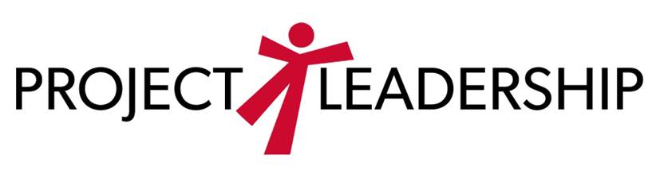

August 2020
Dear Parent,
We understand that you have a child currently in the school system and would like to tell you about the wonderful opportunity provided by the Twenty-first Century Scholars program. The program is available to income eligible 7th, and 8th grade students who enroll in the program and fulfill a pledge of good citizenship to the state of Indiana. If so, they may be eligible for an award of up to the cost of four years or eight semesters of college tuition at any public college or university in Indiana. If the student attends a private institution, the state may award an amount comparable to that of tuition cost at a public institution. If the student attends a participating proprietary school, the state may award a tuition scholarship up to that of Ivy Tech State College.
If your student currently qualifies for free/reduced lunch or if you qualify according to income guidelines, you should enroll your child in this great program. Feel free to contact Project Leadership at 316 W Howard St. Muncie, In 47305 (phone 765-896-8616) for an application. You may also contact your school’s guidance office to get an application.
Online applications are also available at www.scholars.in.gov/enroll. We may also be at some 2020-2021 school events. Look for us at a table in your school, where we will be happy to assist you in the Twenty-first Century Scholars enrollment process.
The deadline for the students to enroll is June 30, 2021. Students may not enroll after June 30th of their 8th grade year. If you are completing the application yourself, be sure to return your application well before the June 30th date, to insure it arrives in Indianapolis on time. Do not let this wonderful opportunity slip by!
Sincerely,

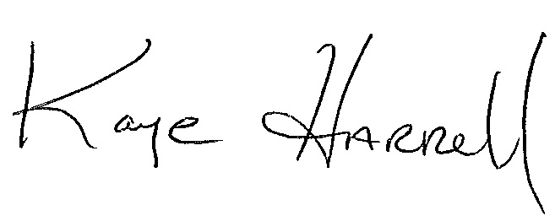

Kaye Harrell
Community Scholarship Liaison
Project Leadership
(765) 896-8616

Return this form to your school office

ONLY IF YOU ARE DENYING PERMISSION

xxxxxxxxxxxxxxxxxxxxxxxxxxxxxxxxxxxxxxxxxxxxxxxxxxxxxxxxxxxxxxxxxxxxxxxxxxxxxxxxxxxxxx

Return this form to the school ONLY if you are denying permission for Project Leadership and Twenty-first Century Scholars to access your child’s information needed to help enroll them in the program. There is no need to return this form if you are granting permission to Project Leadership and the Twenty-first Century Scholars.

Your child’s school would like Twenty-first Century Scholars and Project Leadership personnel to have access to your child’s contact information and information related to determining eligibility for the Twenty-first Century Scholars program.
If you DO NOT want this information released to Twenty-first Century Scholars and Project Leadership personnel, return this signed form to your school’s office no later than September 1, 2020.

I do not want personal information released to Twenty-first Century Scholars or Project Leadership personnel.

__________________________________ ________________________________
Student Name (Printed) Parent Signature

School Name _____________________________

